Experiment 10

AIM: To create a cloning of a vm and test it by loading the previous version/cloned vm.

PROCEDURE:

STEP 1: GO TO VM AND GOTO MANAGE AND CLICK CLONE

STEP 2: CLICK CLONE

STEP 3: SELECT THE FULL CLONE

STEP 4: AFTER CLONE AGAIN OR VM IS OPENED.

OUTPUT

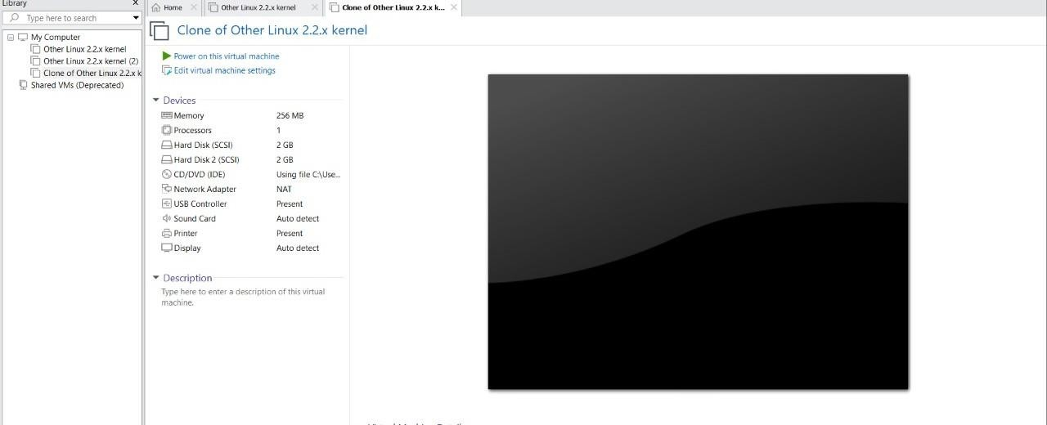

Result: The experiment was executed successfully